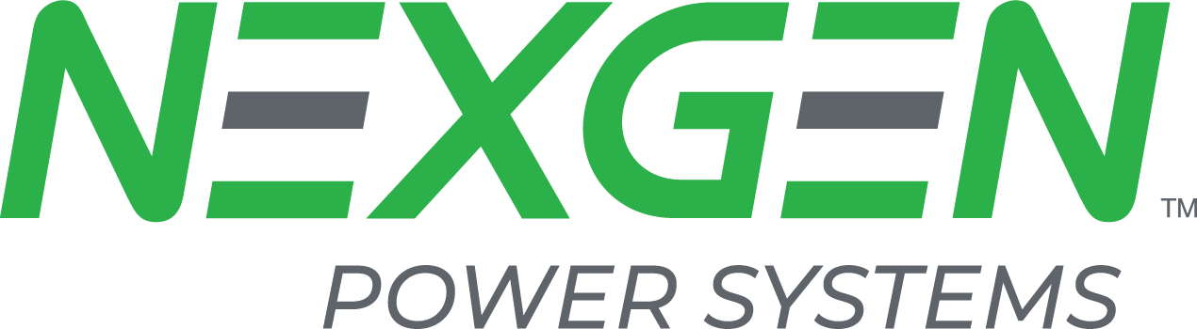

Company Overview
NexGen is changing the power electronics equation and helping our customers stay ahead of the competition by providing them solutions for a more sustainable world.
We build innovative Vertical-GaN™ based systems that enable the next generation of power conversion. Smaller, lighter, and more efficient. Our Vertical-GaN™ based software-scalable power systems have the lowest power losses at the highest power density compared to competitors.
NexGen Power Systems is headquartered in Santa Clara, California. It builds the GaN power devices in a state-of-the-art fabrication facility located in Syracuse, New York. NexGen is developing the world’s best power conversion systems in its brand-new R&D Center of Excellence in Bengaluru, India.
NexGen’s Bengaluru Center of Excellence is powering the future of power electronics by building a complete state-of-the-art system leveraging our unique and proprietary Vertical GaN™ technology. The India team has built the world’s most efficient power systems for Computing and LED platforms, switching at 1+MHz, which makes the systems up to 60% smaller and 50% lighter.
The Bengaluru Center of Excellence is a fast-growing team of engineers in power electronics, mechanical design, firmware and software, testing, and board layout. It also includes global marketing and system applications teams that drive these functions for the company globally. NexGen is proud to be a part of the ‘Make in India’ journey through one of its manufacturing partners.
See our website for more details: www.nexgenpowersystems.com

Staff / Sr Staff / Principal Engineer – Power Electronics
The ideal candidate’s role is to develop high performance switching power supply using new Vertical-GaN™ technology, that enables pushing up performance characteristics such as power density, efficiency and switching frequency.

Qualifications
- Bachelor’s or Master’s degree in Electrical & Electronics or Electronics & Communications Engineering with specialization or experience in Power Electronics.

Desired Knowledge, Skills and Experience
- 3 - 16 years of experience in designing, testing, qualification of power supplies, UPS, Solar inverters, LED drivers or other power electronics products with high frequency power converters with different topologies.
- Good knowledge of power semiconductor devices and characteristics especially MOSFETS, IGBTs, SiC, GAN.
- Understand simulation techniques, fundamental electrical equations
- Stability Analysis
- CE, RE emission, PCB layout implications on EMI.
- Working with instruments like Oscilloscope, Logic Analyzer, Power sources, Electronic Loads etc.
- Experience in any of the following are preferred:
  - Design, testing of magnetics for low and high frequencies
  - Knowledge and experience in DSPs
  - Familiar with power supply regulatory requirements
  - Modeling designs, efficiency and losses of a switching power supply
  - Component selection and alternate sourcing.

Soft Skills
- Strong analytical, problem-solving, and hands-on skills
- Self-driven and thrives when facing open-ended tasks
- Good written and verbal communication skills
- Flexibility to work with varied schedules
- Ability to handle multiple projects simultaneously
- Start-up mentality: fast-paced, flexible and team-oriented
- Good documentation skills

Responsibilities
You are expected to work on any or all the following activities during product development.
- Understand customer requirements and translate to Design Architecture specifications, designing schematics, work with PCB Layout Engineers, Mechanical Design and Thermal Analysis engineers to develop compact, power efficient solutions for end users.
- Develop Verification and Testing plans, develop detailed test procedures and execute the plans on DUTs.
- Debug the circuits for potential design problems as well as problems reported from manufacturing to improve yield and suggest remedies.
- Work with Certification Engineers to get the regulatory compliances, analyze issues and provide solutions.

Job Type: Full-time
Location: Bengaluru, India

